II Parte del parcial.

Estudiante: Guadalupe Castillo 8-929-2252

Modelo conceptual ER

Modelo lógico relacional normalizado

|  |  |  |
| --- | --- | --- |
| BAR | | |
| Pk | Nom_bar | N |
|  | Ciudad | N |
|  | Calle | N |
| Fk | Id_tel_bar | S |

|  |  |  |
| --- | --- | --- |
| AMIGO | | |
| Pk | cedula | N |
|  | Nom_am | N |
|  | Ape_am | N |
|  | Edad | N |
| Fk | Id_tel | N |

|  |  |  |
| --- | --- | --- |
| AMIGO_CV | | |
| Pk (Fk) | cedula | N |
| Pk (Fk) | Nom_cv | N |
|  | Grado_gusto | N |

|  |  |  |
| --- | --- | --- |
| CERVEZA | | |
| Pk | Nom_cv | N |
|  | Marca | N |
|  | Grado_alc | S |

|  |  |  |
| --- | --- | --- |
| CV_BAR | | |
| Pk (Fk) | Nom_cv | N |
| Pk (Fk) | Nom_bar | N |

|  |  |  |
| --- | --- | --- |
| AMIGO_BAR | | |
| Pk (Fk) | cedula | N |
| Pk (Fk) | Nom_bar | N |

|  |  |  |
| --- | --- | --- |
| TEL_AM | | |
| Pk | Id_tel | N |
|  | numero | N |

|  |  |  |
| --- | --- | --- |
| TEL_BAR | | |
| Pk | Id_tel_bar | N |
|  | numero | N |

Modelo físico

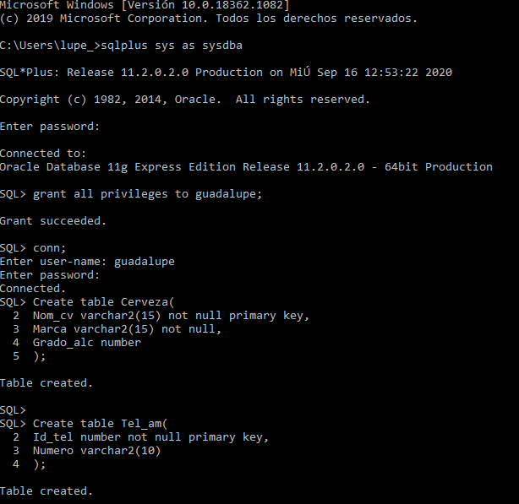 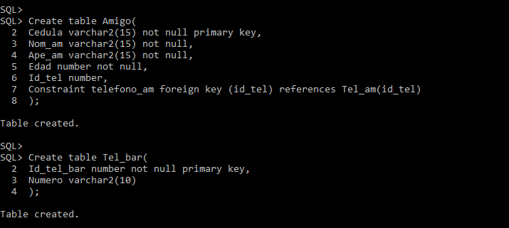 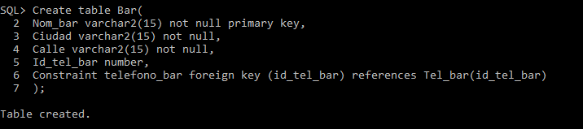

Create table Cerveza(

Nom_cv varchar2(15) not null primary key,

Marca varchar2(15) not null,

Grado_alc number

);

Create table Tel_am(

Id_tel number not null primary key,

Numero varchar2(10)

);

Create table Amigo(

Cedula varchar2(15) not null primary key,

Nom_am varchar2(15) not null,

Ape_am varchar2(15) not null,

Edad number not null,

Id_tel number,

Constraint telefono_am foreign key (id_tel) references Tel_am(id_tel)

);

Create table Tel_bar(

Id_tel_bar number not null primary key,

Numero varchar2(10)

);

Create table Bar(

Nom_bar varchar2(15) not null primary key,

Ciudad varchar2(15) not null,

Calle varchar2(15) not null,

Id_tel_bar number,

Constraint telefono_bar foreign key (id_tel_bar) references Tel_bar(id_tel_bar)

);